## Distributed Work/ROR Internal Data report: (Giving help)

Request:

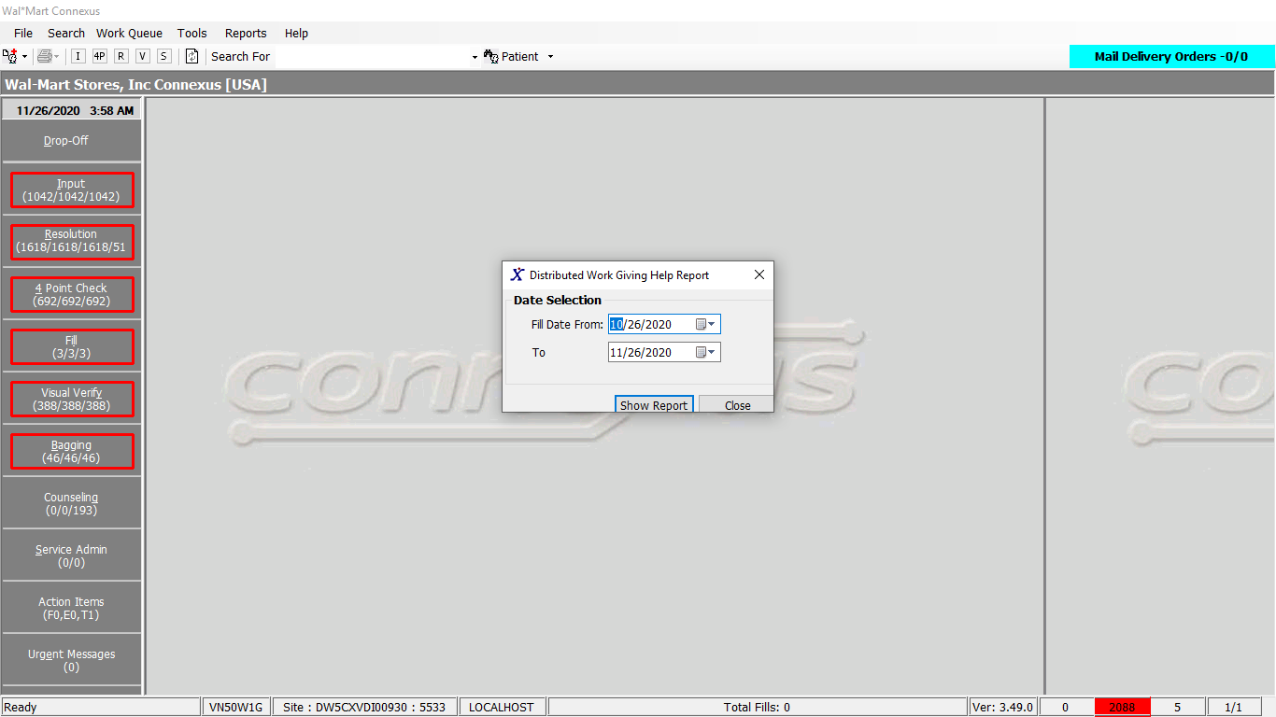

Response:

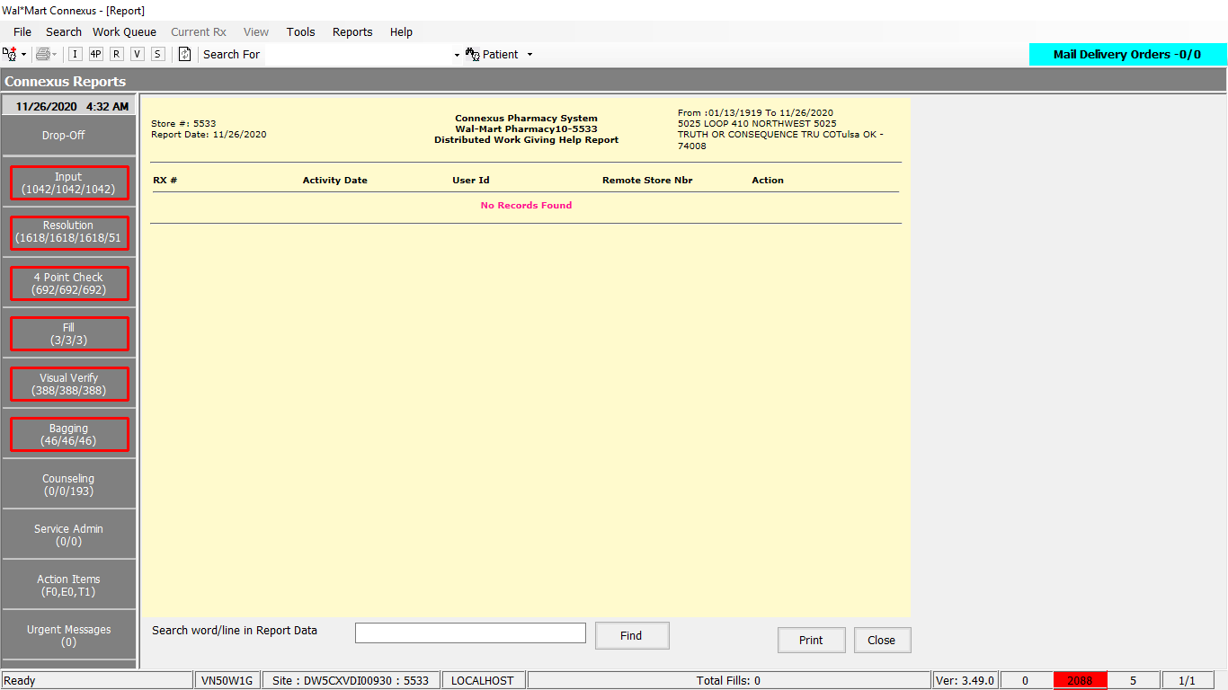

Queries:

Friend Const GetRorInternalData As String = "SELECT rua.remote_rx_nbr , rua.activity_ts, rua.activity_userid, rua.remote_store_nbr, rua.activity_code, rua.work_que_code, pct.code_desc FROM ror_user_activity rua, OUTER pharmacy_code_txt pct WHERE rua.remote_store_nbr IS NOT NULL AND pct.code_id = rua.activity_code"

DAL

Public Function GetRorInternalData(ByVal siteId As Integer,

Optional ByVal startFillDate As DateTime = Nothing,

Optional ByVal endFillDate As DateTime = Nothing,

Optional ByVal rorStoreNbr As Integer = 0) _

As List(Of GetRorInternalDataInfoBE) Implements IReportDAL.GetRorInternalData

Dim sqlString As New StringBuilder

Dim getRorInternalDataBEList As New List(Of GetRorInternalDataInfoBE)

Dim dummyDate As Date

Dim paramList As New List(Of DbParameter)

Using (New Tracer(ConnexusCommonConstants.ConnexusTracer))

sqlString.Append(ReportQueries.GetRorInternalData)

If rorStoreNbr > 0 Then

sqlString.Append(" AND rua.remote_store_nbr = ? ")

paramList.Add(ParameterHelper.BuildParameter("RemoteStoreNbr", DbType.Int32, rorStoreNbr))

End If

If Date.TryParse(startFillDate.ToString(CultureInfo.InvariantCulture), dummyDate) = True And Date.TryParse(endFillDate.ToString(CultureInfo.InvariantCulture), dummyDate) = True Then

If Not startFillDate < DateTime.MinValue And Not endFillDate < DateTime.MinValue Then

sqlString.Append(" AND DATE(rua.activity_ts) >= ? AND DATE(rua.activity_ts) <= ? ")

paramList.Add(ParameterHelper.BuildParameter("FillStartDate", DbType.String, String.Format(CultureInfo.InvariantCulture, "{0:MM/dd/yyyy}", startFillDate)))

paramList.Add(ParameterHelper.BuildParameter("FillEndDate", DbType.String, String.Format(CultureInfo.InvariantCulture, "{0:MM/dd/yyyy}", endFillDate)))

End If

End If

sqlString.Append(" ORDER BY work_que_code, activity_code, activity_ts")

Dim dataReader As IDataReader = ExecuteReader(DatabaseEnum.rx21c, siteId, sqlString.ToString, paramList)

Dim getRORInternalDataBE As GetRorInternalDataInfoBE

While dataReader.Read

getRORInternalDataBE = New GetRorInternalDataInfoBE

If Not dataReader.IsDBNull(dataReader.GetOrdinal("activity_code")) Then

getRORInternalDataBE.ActivityCode = CInt(dataReader("activity_code"))

End If

If Not dataReader.IsDBNull(dataReader.GetOrdinal("remote_store_nbr")) Then

getRORInternalDataBE.RemoteStoreNbr = CInt(dataReader("remote_store_nbr"))

End If

If Not dataReader.IsDBNull(dataReader.GetOrdinal("activity_ts")) Then

getRORInternalDataBE.ActivityTs = CDate(dataReader("activity_ts"))

End If

If Not dataReader.IsDBNull(dataReader.GetOrdinal("activity_userid")) Then

getRORInternalDataBE.ActivityUserId = CStr(dataReader("activity_userid")).Trim

End If

If Not dataReader.IsDBNull(dataReader.GetOrdinal("code_desc")) Then

getRORInternalDataBE.CodeDesc = CStr(dataReader("code_desc")).Trim

End If

If Not dataReader.IsDBNull(dataReader.GetOrdinal("remote_rx_nbr")) Then

getRORInternalDataBE.RemoteRxNbr = CInt(dataReader("remote_rx_nbr"))

End If

If Not dataReader.IsDBNull(dataReader.GetOrdinal("work_que_code")) Then

getRORInternalDataBE.WorkQueCode = CInt(dataReader("work_que_code"))

End If

getRorInternalDataBEList.Add(getRORInternalDataBE)

End While

If getRorInternalDataBEList.Count > 0 Then

Return getRorInternalDataBEList

Else

Return Nothing

End If

End Using

End Function